MINI PROJECT REPORT

Future of IoT in Smart Cities

Submitted By
Eeda Harshini
IoT Internship
College name: Megha Institute of Engineering and Technology for Women
Date: June 2026

Introduction to IoT and Smart Cities

The Internet of Things (IoT) refers to a network of physical devices connected to the internet that can collect, share, and process data. These devices include sensors, cameras, smart meters, vehicles, and household appliances. IoT enables communication between devices without requiring constant human intervention.
With rapid urbanization, cities face challenges such as traffic congestion, energy consumption, pollution, and inefficient public services. To address these issues, governments are adopting smart city technologies powered by IoT.
A smart city uses interconnected devices and intelligent systems to improve urban infrastructure and enhance the quality of life for citizens. Through real-time monitoring and data analysis, city administrators can make informed decisions and optimize resource utilization.
IoT technologies are becoming essential for creating sustainable, efficient, and environmentally friendly cities. By integrating sensors, communication networks, cloud computing, and data analytics, smart cities can deliver better services while reducing operational costs.
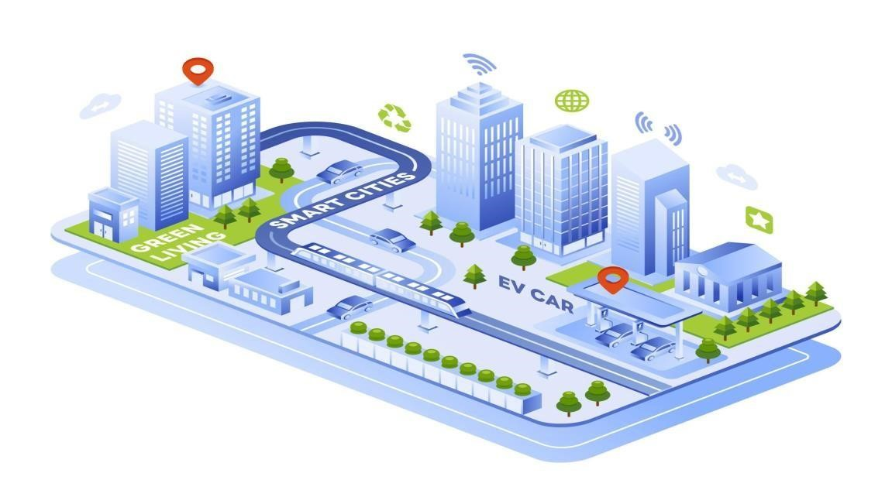

Smart Traffic Management and Smart Parking
IoT helps manage traffic through sensors, cameras, and connected traffic signals. Smart parking systems use sensors to detect available spaces and guide drivers efficiently.
Benefits:
- Reduced congestion
- Lower fuel consumption
- Faster emergency response
- Better transportation management
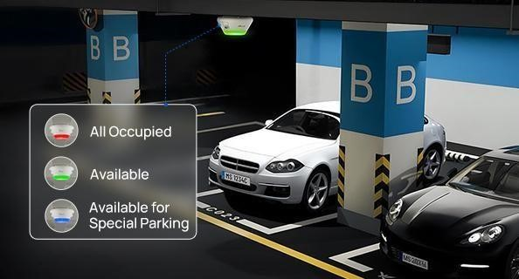

Fig: Smart Parking
Finding parking spaces in crowded urban areas wastes fuel and increases traffic.
Smart parking systems use sensors installed in parking spaces to detect availability.
Drivers can access real-time parking information through mobile applications. This helps reduce search time, lowers fuel consumption, and improves traffic flow.
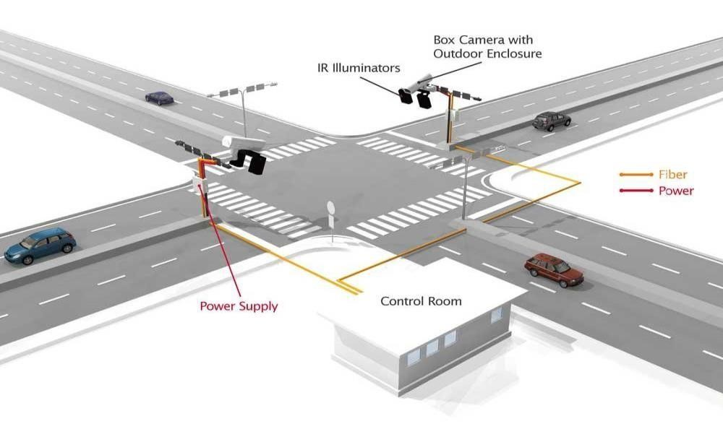

Fig: Smart Traffic Managemet
Traffic congestion is one of the biggest problems in modern cities. IoT helps manage traffic through sensors, cameras, and connected traffic signals.
Sensors installed on roads collect information about vehicle movement and traffic density. This data is transmitted to traffic control centers where intelligent systems analyze conditions in real time. Traffic signals can then automatically adjust their timing to reduce congestion.
Emergency vehicles such as ambulances can also receive priority through connected traffic systems, helping save valuable time during emergencies.

Street Lighting and Waste Management
IoT-enabled street lights adjust brightness automatically based on movement and environmental conditions. Smart waste bins notify collection services when they are full.
Benefits:
- Energy conservation
- Reduced costs
- Cleaner environment
- Improved public services

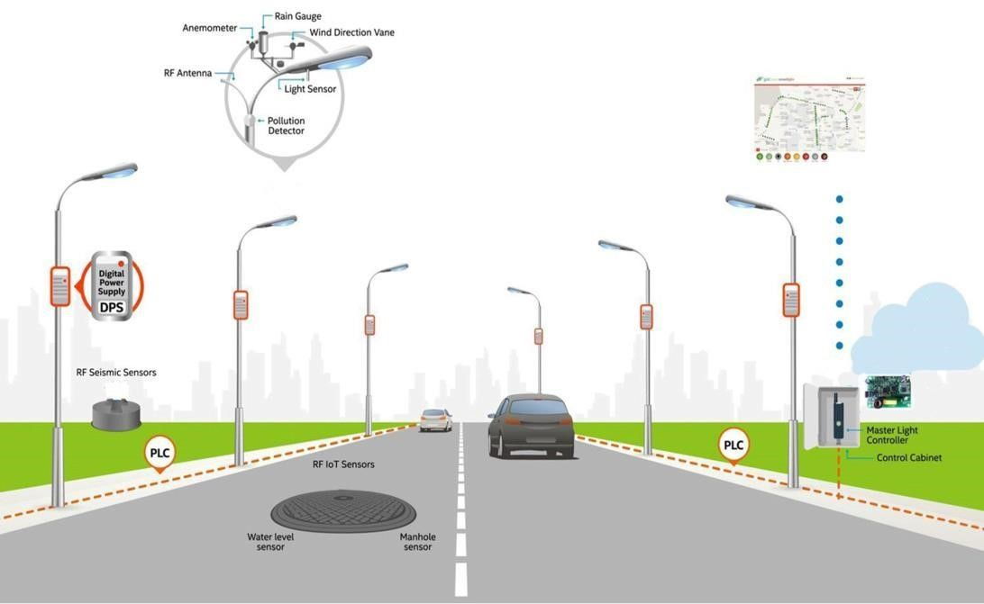

Fig: Smart Street Lighting
Traditional street lights operate continuously regardless of traffic or weather conditions. IoT-enabled street lights use sensors to monitor movement and environmental conditions.
These lights automatically adjust brightness levels based on pedestrian activity and vehicle movement. During low-traffic periods, the lights can dim to save energy.
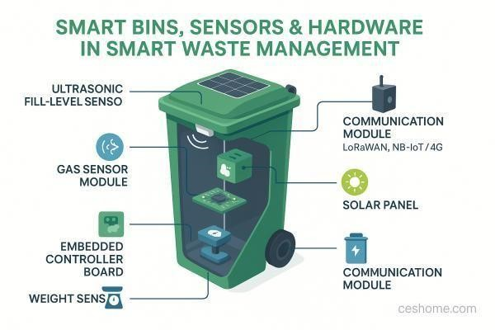

Fig: Smart Waste Management
Waste management is another important application of IoT in smart cities.
Smart waste bins contain sensors that monitor garbage levels. When bins become full, notifications are sent automatically to waste collection departments.
This allows collection vehicles to follow optimized routes, reducing fuel usage and ensuring cleaner streets.

Smart Water Monitoring and Smart Energy Systems
IoT sensors monitor water quality, leakage, pressure, and consumption. Smart energy systems use connected meters to track electricity usage in real time.

Benefits:
- Reduced water wastage
- Improved water quality
- Energy conservation
- Better infrastructure management
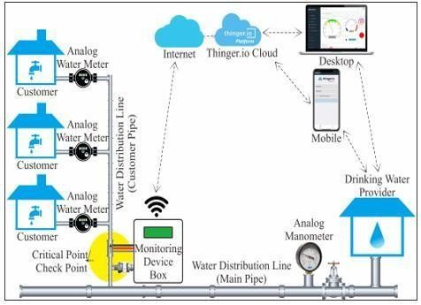
Fig: Smart Water Monitoring
Water scarcity is a major concern in many cities. IoT-based water monitoring systems use sensors to detect water quality, leakage, pressure, and consumption levels.
Authorities can identify pipeline leaks quickly and take corrective action before significant water loss occurs.
Continuous monitoring also helps maintain water quality standards and ensures efficient distribution.
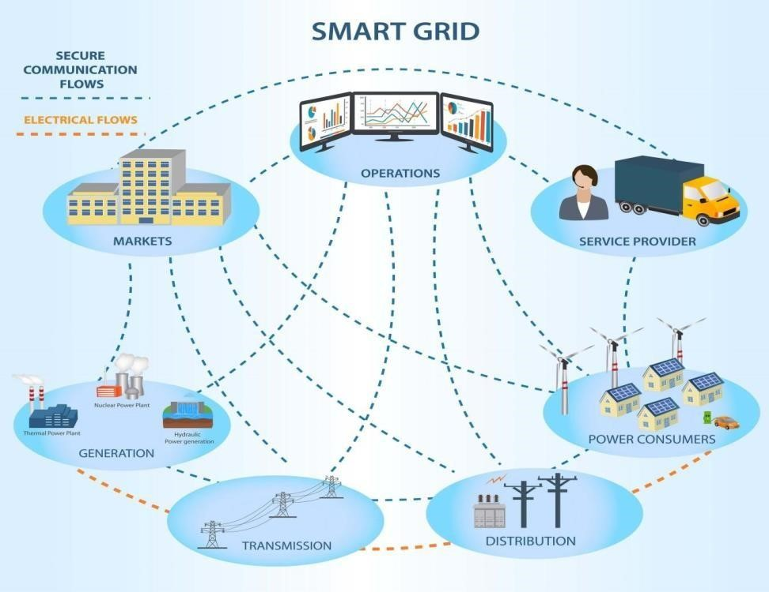

Fig: Smart Energy Systems
Smart energy systems use connected meters and sensors to monitor electricity consumption in real time.
Consumers can track their energy usage through mobile applications and make informed decisions to reduce consumption.
Utility companies benefit by improving load management and minimizing power outages.

Challenges of IoT in Smart Cities
Major challenges include cybersecurity risks, privacy concerns, high implementation costs, technical complexity, and management of large volumes of data.

Security Issues
As more devices connect to the internet, cybersecurity risks increase. Unauthorized access to smart city systems can disrupt essential services.

Privacy Concerns
IoT devices collect large amounts of personal and public data. Protecting citizen privacy is a major responsibility for city administrators.

High Implementation Costs
Deploying sensors, communication networks, cloud infrastructure, and maintenance systems requires substantial investment.

Technical Challenges
Managing thousands of connected devices can be complex. Device compatibility and software updates are ongoing challenges.

Data Management
Large volumes of data generated by IoT devices require efficient storage, processing, and analysis systems.


Fig: Challenges of IoT in Smart Cities
Future Scope and Conclusion
Future smart cities will integrate AI, 5G, machine learning, autonomous vehicles, smart healthcare, and intelligent transportation systems.
The future of IoT in smart cities is highly promising. Emerging technologies such as Artificial Intelligence (AI), 5G networks, machine learning, and edge computing will further enhance smart city capabilities.
Future developments may include: Autonomous
vehicles
AI-powered traffic control systems Smart healthcare monitoring
Intelligent environmental monitoring
Smart public transportation
Sustainable urban planning

Conclusion:
IoT is transforming cities into smarter, safer, and more sustainable environments while improving efficiency and quality of life.
The Internet of Things is transforming cities into smarter, safer, and more sustainable environments. Through applications such as traffic management, smart lighting, waste management, water monitoring, and energy optimization, IoT improves the efficiency of urban infrastructure and enhances citizens' quality of life.
Although challenges such as cybersecurity, privacy, and implementation costs remain, continued technological advancements will drive the growth of smart cities worldwide. IoT will play a crucial role in building the cities of the future.

References: ibm.com
Cisco.com
Oracle.com

